Please tick appropriate project:

ENG5059P (MSc)

Student Name | Wenhan Chan
Student GUID Number | 2636906C
Degree programme | ENG5059P: MSc Project
Working Title of Project | Analyzing the Microbial Ecology of Contaminated Soils
Name of Supervisor(s) | Umer Ijaz
Academic year | 2021-2022

Introduction (max 1 page)
Environmental pollution is a legacy of industrialisation that poses a threat to human health and the environment. Landfill disposal is the preferred method of treating contaminated soils, but it cannot provide a fundamental solution to the problem of soil contamination.

The use of microorganisms to biodegrade contaminated soil in order to solve the soil contamination problem. It has become important to understand the interactions and mechanisms of microbial communities in the biodegradation of contaminated soils, especially considering polyaromatic hydrocarbons (PAHs). As Caroline et al. (2019) show, PAHs which are recognised as lipophilic legacy organic contaminants found in crude oil. It is generated during the burning of coal and organisms. PAHs have been detected as carcinogenic or mutagenic substances, for example, naphthalene, phenanthrene or benzene (Caroline et al., 2019). As they are currently on the priority list, it is particularly important to study the biodegradation of PAHs by microorganisms.

This project will provide a cross-sectional comparison of microbial communities from two contaminated sites, COV soils from the UK and CH soils from Switzerland. Both sites have 16S rRNA samples and are contaminated with PAHs. The datasets with 16S rRNA samples were analysed via R Studio software. It was guided by recent advances in microbial community assembly mechanisms to develop an analytical strategy that elucidates the role of the environment and reveals key members of the microbial communities representative of these sites.

Aims/Objectives of project
- To do a cross-sectional comparison of microbial communities of soils from two contaminated sites, COV (United Kingdom) and CH (Switzerland).
- Using data analysis to elucidate the role played by the environment and reveal key members of the microbial consortia representing these sites.

Resources required
- R and R studio
- Dataset
- NULL MODELING algorithms
- GLLVM (Generalised latent linear variable model)
- CODA LASSO (compositional balance method)

GANTT chart


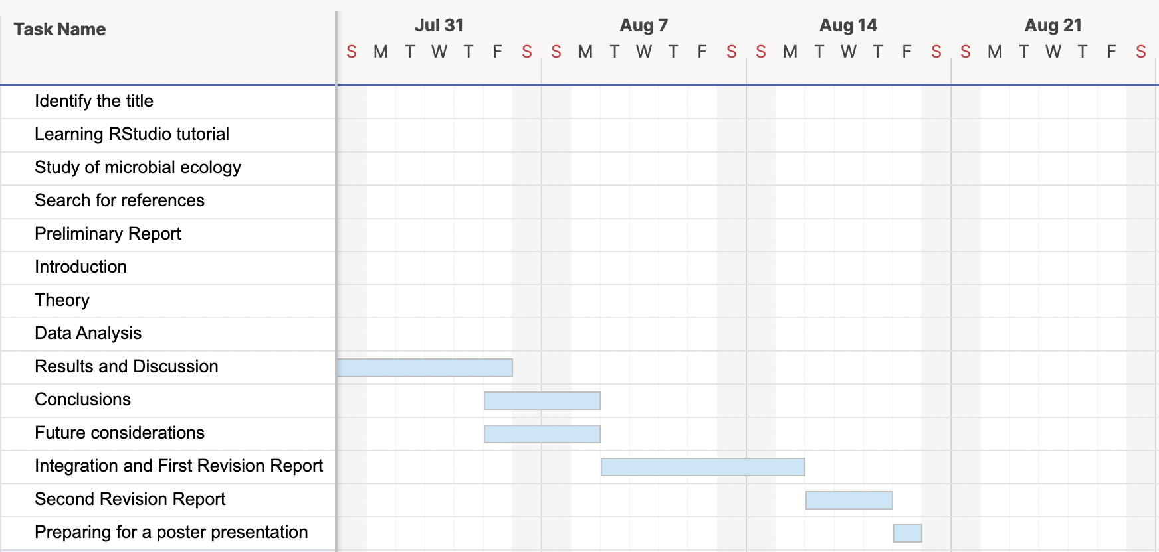

Risk assessment
- Risk: Unavailability of data
Likelihood without control measures: Improbable
Severity: Slight
Control measures to mitigate risk: The data for the project is provided by the supervisor, and. is available on a shared repository as well as a backed up
Likelihood with control measures: Improbable

- Risk: Data corruption
Likelihood without control measures: Unlikely
Severity: Moderate
Control measures to mitigate risk: The project data is provided on a Dropbox repository. (which maintains history for 30 days), as well as saved as a local copy on personnel computer, and in the event of data corruption, the extra copies will be used
Likelihood with control measures: Unlikely

- Risk: Mental fatigue
Likelihood without control measures: Likely
Severity: Moderate
Control measures to mitigate risk: The project involves support of additional volunteers (who. are PhD students/PDRAs associated with the supervisor's lab), as well as benefits from working in a team environment, with specific and measurable weekly milestones, ensuring the work is balanced in the duration of the project. The training and support is provided by the supervisory team, and access to statistical tools (existing programming codes from numerous projects) ensures reduced anxiety and concerns.
Likelihood with control measures: Likely

